Afbeelding met wolk, buitenshuis, boom, meer

Door AI gegenereerde inhoud is mogelijk onjuist.

Weather extremes cause water-related issues throughout all of Europe. Both floodings and droughts are alternating, recurring problems. Within the project *Rural Roadwater Rescue*, we aimed to find a way to complement these situations by collecting road runoff water during wet periods, to utilize the water during dry spells.

We ventured out with the question *Is it possible to collect, clean and distribute road water to overcome local droughts and tackle flooding issues?*

This challenge was aced head-on by a consortium of six European organizations, supported by EU Interreg North West Europe. Based on our knowledge and experiences we composed a strategy to develop *Climate Adaptive Water Hubs*; a means to make road water locally available. This strategy integrates technical, ecological and juridical approaches. The findings and future steps will be presented and discussed at the conference.

**Conference program**

Keynote speaker and chair dr. [*Marjolein Vanoppen*](https://www.marjoleinvanoppen.be/projecten) – a Flemish water versatility scientist and publicist

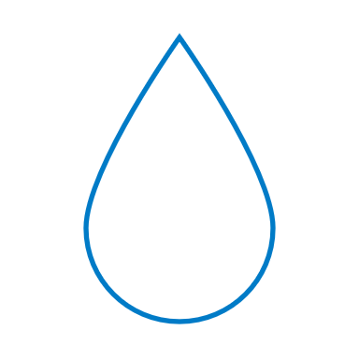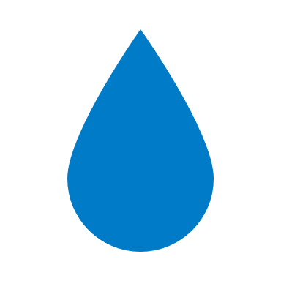

Plenary presentation - *Climate Adaptive Water Hubs Strategy*



Strategy workshops -Participation and community engagement, policy and legal framework, and technical solutions



Information market - For expanding the network and obtain more knowledge



Panel discussion - Realising *Climate Adaptive Water Hubs*

Afbeelding met buitenshuis, hemel, boom, Commercieel gebouw

Door AI gegenereerde inhoud is mogelijk onjuist.

**Conference venue**

**Marie-Elisabeth Belpairebuilding**

**Simon Bolivarlaan 7**

**1000 Brussel**

**Pre-conference fieldtrip**

The Dutch road authority Rijkswaterstaat will host a fieldtrip to the highway 58 near Eindhoven, the Netherlands on May 19th,. Within this rapidly evolving area, Rijkswaterstaat and companies work together under the banner of[*InnovA58*](https://www.innova58.nl/default.aspx) to develop and test innovations in road construction and maintenance. During the fieldtrip, we will visit various stakeholders and view some experiments in relation to *Climate Adaptive Water Hubs*. In the evening we can eat together near Eindhoven and travel to Brussels together by bus.

**Suggested hotels**

**Brussels**

* [Best Western City Centre](https://www.bestwestern.com/en_US/book/hotels-in-brussels/best-western-city-centre/propertyCode.92933.html)

*Square Victoria Regina 9*

* [Hotel Europacity](https://www.hoteleuropacity.com/EN/home.html)

*Rue de Brabant 80*

* [Hotel le Dome](https://www.hotel-le-dome.be/nl/)

*Boulevard du Jardin Botanique 9-12*

**Eindhoven**

* [Hotel Mariënhage](https://www.marienhage.com/)

*Kanaalstraat 4*

* [Art hotel](https://westcordhotels.nl/hotel/hotel-eindhoven/)

*Lichttoren 22*

* [The Social Hub](https://www.thesocialhub.co/eindhoven/)

*Stationsweg 1*

**The Rural Roadwater Rescue conference is hosted by:**

Afbeelding met schermopname, tekst, ontwerp

Door AI gegenereerde inhoud is mogelijk onjuist. Afbeelding met Graphics, grafische vormgeving, tekenfilm, clipart

Door AI gegenereerde inhoud is mogelijk onjuist. Afbeelding met Graphics, grafische vormgeving, symbool, Kleurrijkheid

Door AI gegenereerde inhoud is mogelijk onjuist.   Afbeelding met Lettertype, Graphics, schermopname, logo

Door AI gegenereerde inhoud is mogelijk onjuist.

Rijkswaterstaat, Ministry of Infrastructure and Water Management *(The Netherlands)*Cerema, Centre for Studies on Risks, the Environment, Mobility and Urban Planning *(France)*Cooperative Kloostersland *(The Netherlands)*DVGW Water Technology Center *(Germany)*Flanders Envirnoment Agency *(Belgium)*Interuniversitair Micro Electronica Centrum vzw *(Belgium)*